**Testing Concepts**

Lesson 03 : Testing throughout the Software Life Cycle

Introduction of SDLC and V-Model

There are some distinct test phases that take place in each of the software life cycle activity

It is easier to visualize through the famous Waterfall development model and V- model of testing. The V proceeds from left to right, depicting the basic sequence of development and testing activities. The V model is valuable because it highlights the existence of several levels or phases of testing and depicts the way each relates to a different development phase.

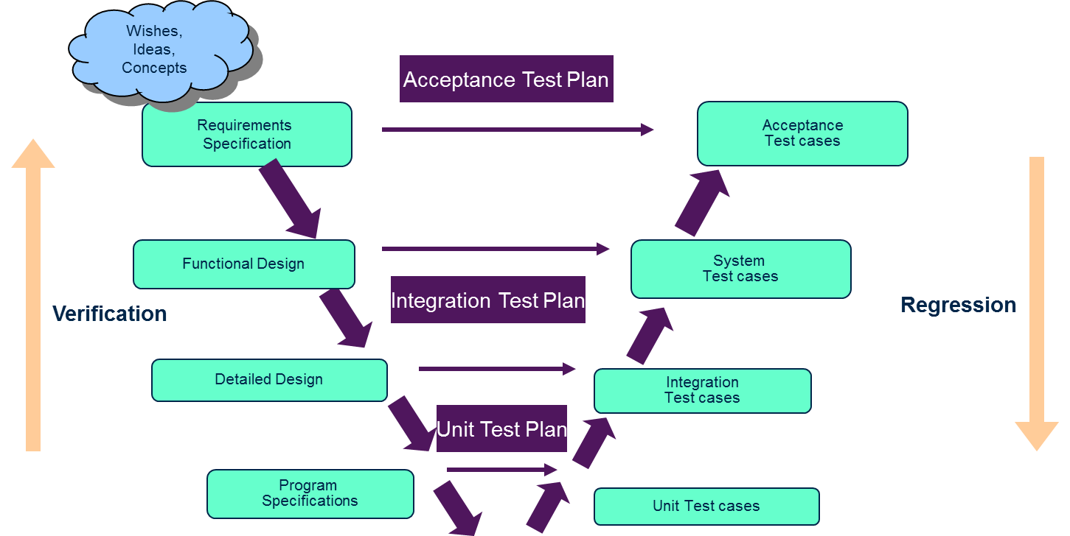

Agile Development – Extreme Programming (XP)

XP is one of the most well-known agile development life cycle models.

Some characteristics of XP are:

It promotes the generation of business stories to define the functionality. It demands an on-site customer for continual feedback and to define and carry out functional acceptance testing. It promotes pair programming and shared code ownership amongst the developers

It states that component test scripts shall be written before the code is written and those tests are automated. It states that integration and testing of the code shall happen several times a day. It focuses on implementing the simplest solution to meet today's problems

Testing Phases:

**Unit (Component) testing**

Unit testing is code-based and performed primarily by developers to demonstrate that their smallest pieces of executable code function suitably.

**Integration testing**

Integration testing demonstrates that two or more units or other integrations work together properly, and tends to focus on the interfaces specified in low-level design.

**System testing**

System testing demonstrates that the system works end-to-end in a production-like environment to provide the business functions specified in the high-level design.

**Acceptance testing**

Acceptance testing is conducted by business owners and users to confirm that the system does, in fact, meet their business requirements

Types of System Testing:

